GRAMMAIRE – Les Temps du Passé
Formes – Constructions - Sens
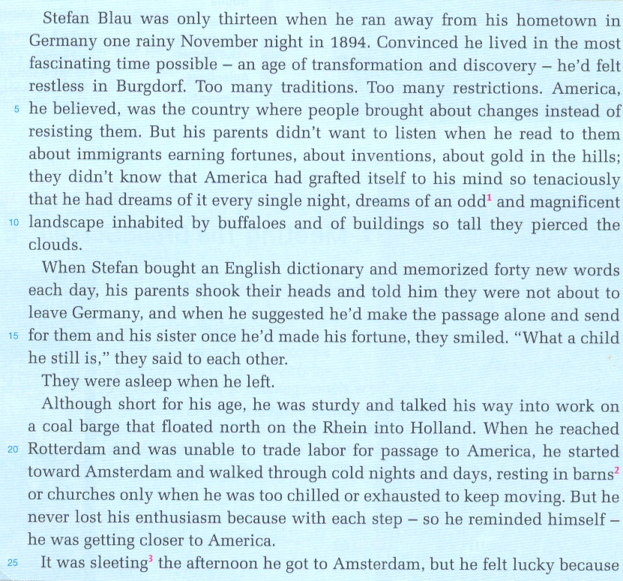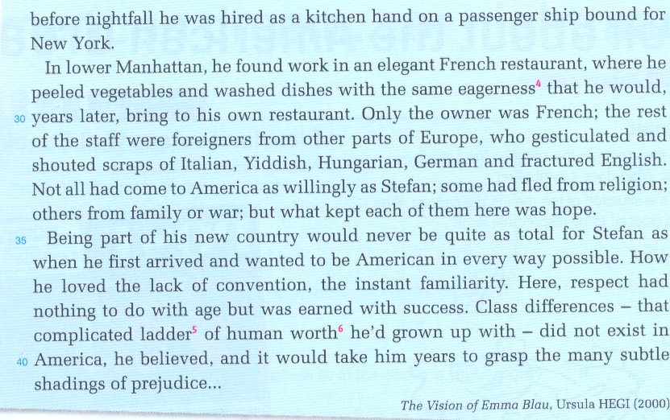
- Souligne/Surligne les groupes verbaux renvoyant au passé.
- En utilisant les éléments ci-dessous, retrouve les constructions des différents groupes verbaux et écris-les en face des formes correspondantes:
BE – HAVE – DO - WILL– V-ing – V-ED – V-EN – BV – NOT

- Preterit simple : forme affirmative: V-ED forme négative : DID NOT + BV
- Pluperfect/past perfect : …HAD (+NOT) + V-EN……….
- Preterit BE-ING : …WAS (+NOT) + V-ing…………………….
- “Conditionnel” : …WOULD (+NOT) + BV…………………………….

- Retrouve le sens de chaque forme :
- … Preterit simple ….. : Sert à exprimer des actions ou états qui ont eu lieu dans le passé. Temps du récit, de la narration.
- … Preterit BE-ING ….. : Sert à exprimer des actions en cours dans la passé. Sert à signaler qu’une action a eu lieu PENDANT une autre action dans la passé.
- … Pluperfect/past perfect .. : Sert à exprimer des actions passées qui se sont déroulées avant d’autres actions elles-mêmes passées.
- …… « Conditionnel » ….. : Sert à se projeter le futur par rapport à une action passée.

- Place les 4 formes les unes par rapport aux autres sur la frise chronologique:

Pluperfect/past perfect Preterit BE-ING Preterit simple « Conditionnel »

présent
- Voir dans la Manuel
Le Preterit simple (p.212-213)
Le Preterit en be + V-ing (p.213) → ex 4 p. 213.
Le Past Perfect simple (p.215) → ex 7, 8 p.215.
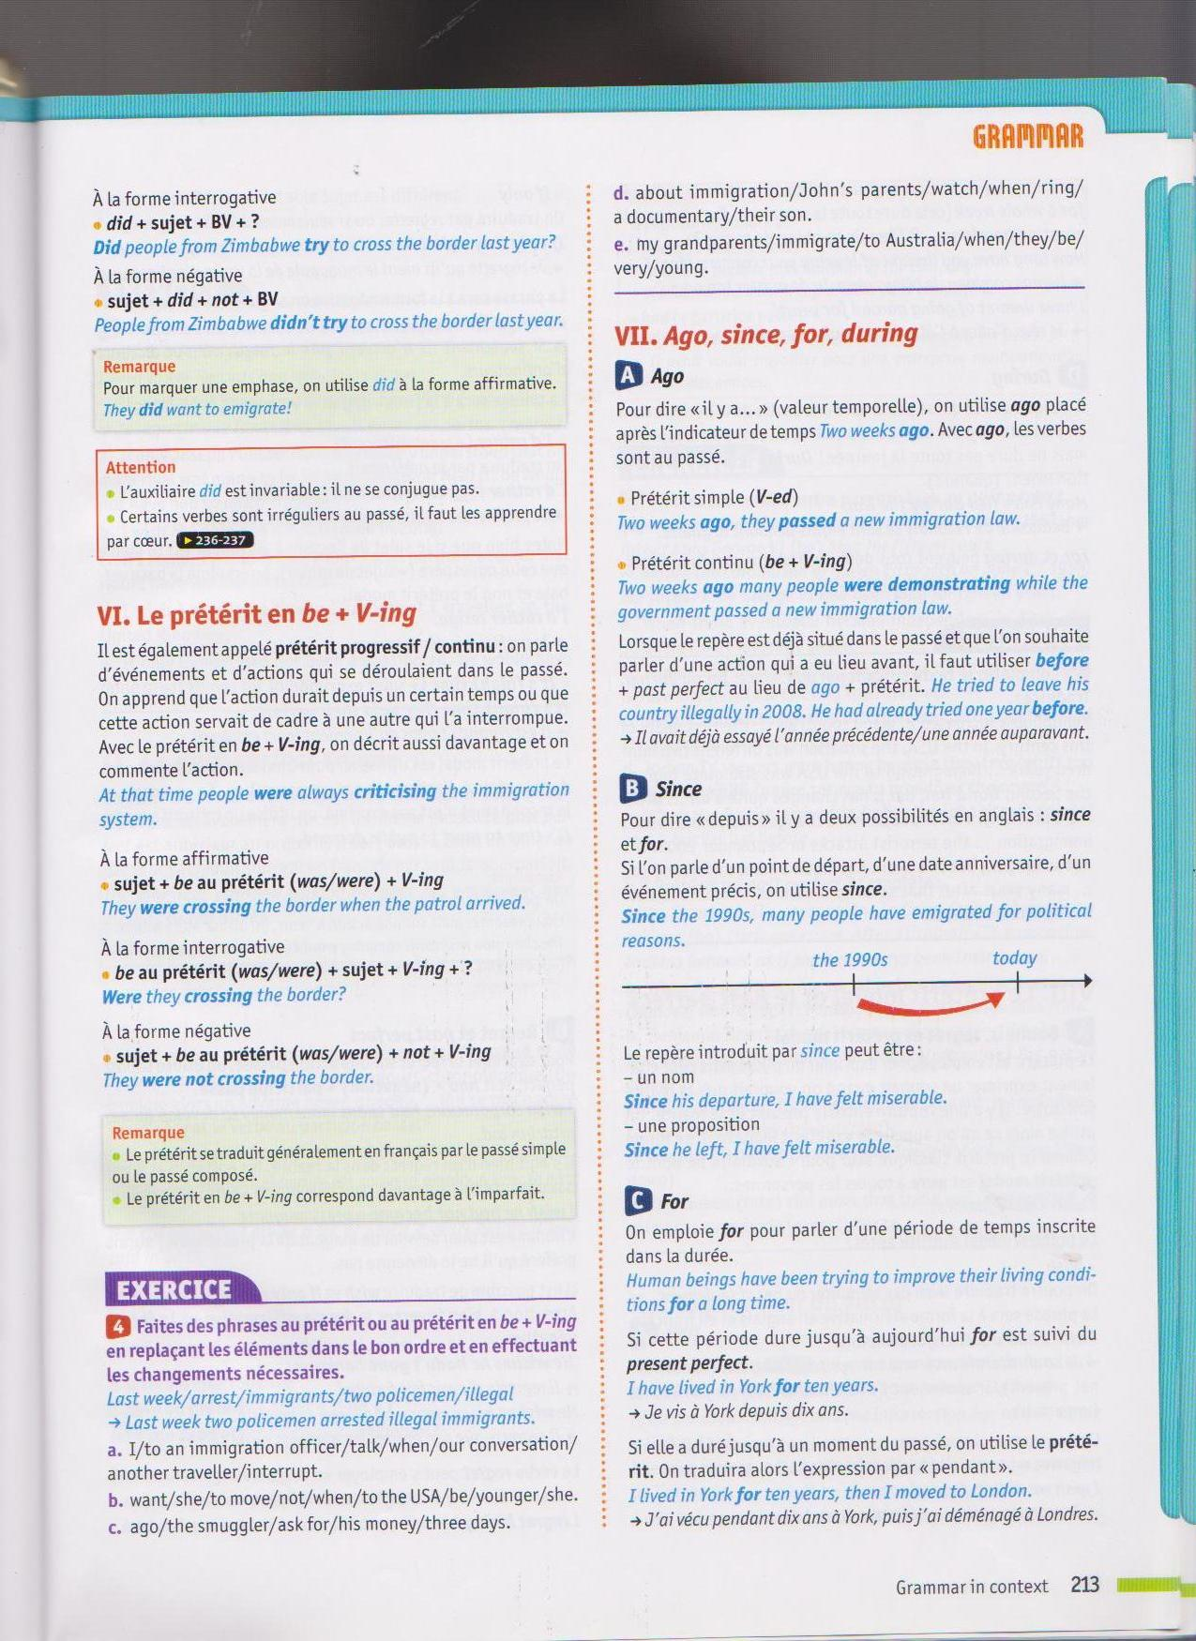
- I was talking to an immigration officer when another traveller interrupted our conversation.
- When she was younger she did not want to move to the USA.
- Three days ago the smuggler asked for his money.
- John’s parents were watching a documentary about immigration when their son rang.
- My grandparents immigrated to Australia when they were very young.
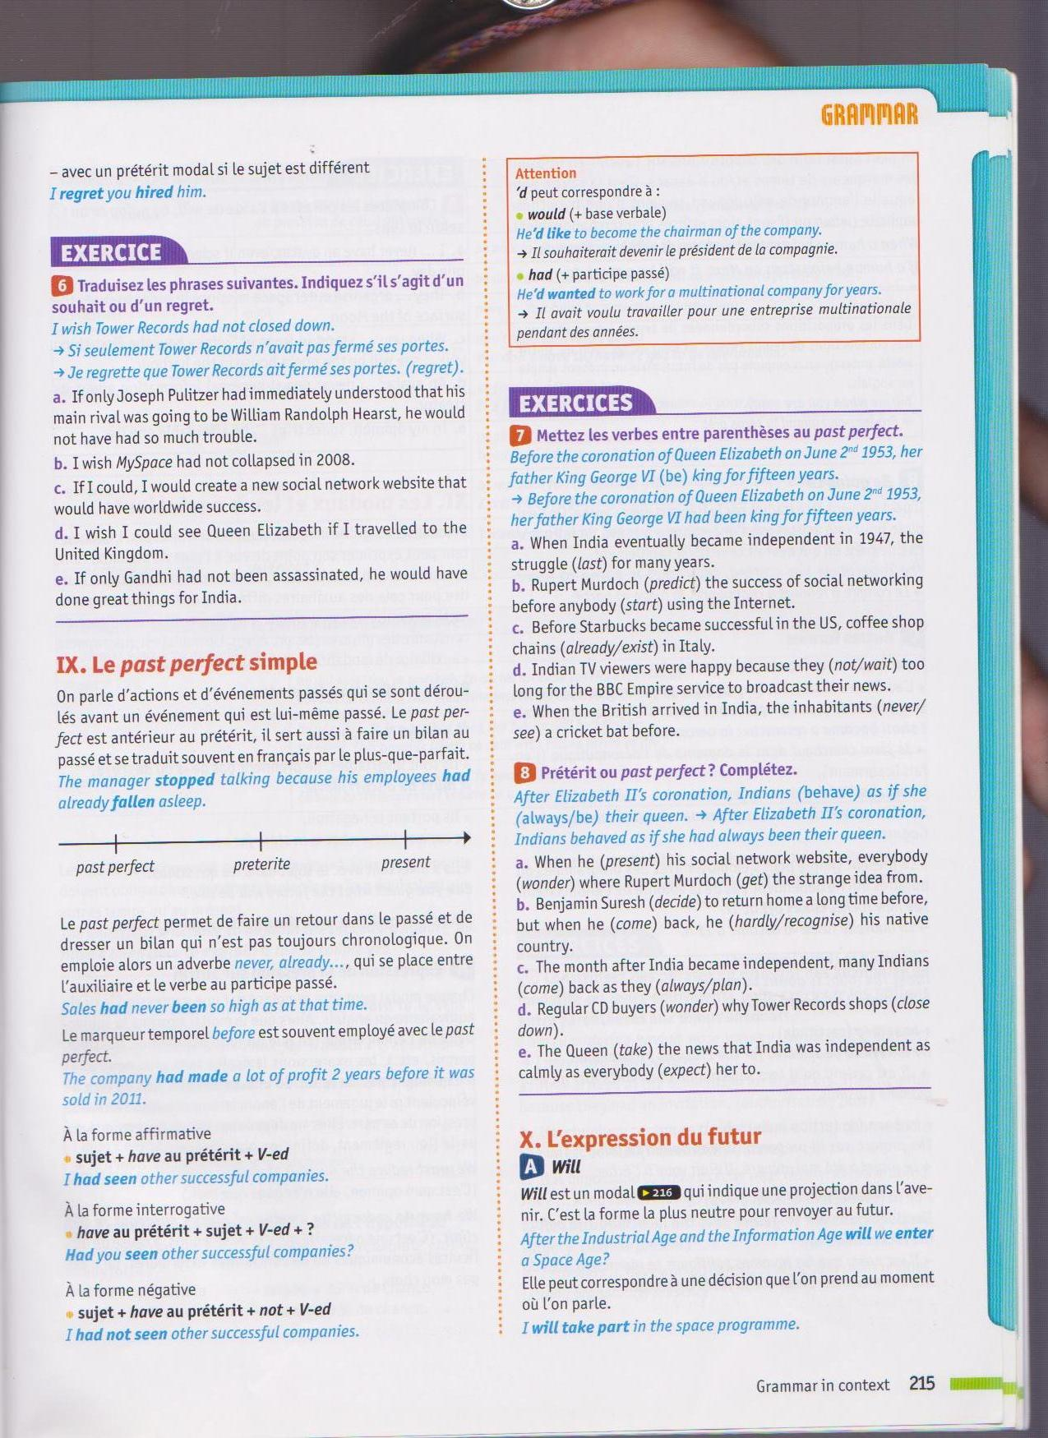
ou au preterit simple
- …the struggle had lasted for many years.
- RM had predicted the success of social networking before anybody started using the Internet.
- …coffee shop chains already existed in Italy.
- …they did not wait too long for the BBC Empire service to broadcast their news.
- … the inhabitants had never seen a cricket bat before.

- When he presented his social network website, everybody wondered where RM had got the strange idea from.
- BS had decided to return home a long time before, but when he came back, he hardly recognized his native country.
- .. many Indians came back as they had always planned.
- Regular CD buyers wondered why TR (had) closed down.
- The Queen took the news that India was independent as calmly as everybody (had) expected her to.

- Superbonus

réguliers |  | irréguliers
LIVE  BELIEVE  WANT LISTEN  GRAFT  PIERCE  MEMORIZE  SUGGEST  SMILE  TALK  FLOAT  REACH  START  WALK  REMIND  SLEET  HIRE  PEEL  WASH  GESTICU…  SHOUT  ARRIVE  LOVE  EARN | vivre  croire  vouloir  écouter  (se) greffer  percer  suggérer  parler  atteindre  commencer  marcher  se rappeler  embaucher  éplucher  laver  crier, brailler  gagner (travail) | BE  RUN  FEEL  BRING  READ  KNOW  HAVE  BUY  SHAKE  TELL  SAY  MAKE  LEAVE  LOSE  GET  FIND  COME  FLEE  KEEP  GROW UP  TAKE | was/Were  ran  felt  brought  read  knew  had  bought  shook  told  said  make  left  lost  got  found  came  fled  kept  grew up  took | been  run  felt  brought  read  known  had  bought  shaken  told  said  made  left  lost  got  found  come  fled  kept  grown up  taken | être  courir, diriger  ressentir, se sentir  apporter  lire  savoir, connaître  avoir, faire (un rêve)  acheter  secouer  dire, raconter  dire  faire, fabriquer  quitter, partir  perdre  devenir, obtenir, …  trouver  venir  fuir  garder  grandir  prendre

